Credit Card Transaction Report
Week_Start_Date

Revenue
Q3Q2Q1
Q4
Power BI Desktop
All 

57M
MedHigh
Low
Total Interest

8M
Trans Amount

46M
Trans Count

667K
QTR Revenue and total trans count
Sum of Revenue Sum of total_trans_ct
F
M

20M

15M
Sum of Revenue
Card_Category   | Sum of Revenue | Sum of total_trans_amt | Sum of Interest_Earned
Blue | 4,71,88,611.62 | 37840749 | 6614173
Gold | 25,33,682.16 | 2091362 | 384755
Platinum | 11,35,608.05 | 953314 | 161629
Silver  Total | 56,59,108.98  5,65,17,010.81 | 4647596  45533021 | 821923  7982480

10M

5M

0M
173.2K

14.0M 13.8M 14.2M 14.5M

166.6K

164.2K
163.3K

Q1 Q2 Q3 Q4

170K

165K

Revenue by Card Category
SilverBluePlatinum
Gold
Sum of total_trans_ct

Swipe
36M

Revenue by Expenditure type
Revenue by Education level
Revenue by Customer Job

Chip

Online 4M

17M

Bills
14M
Graduate
23M
Businessman
18M

Entertainment

Fuel
10M

10M
High School

Unknown
11M

9M
White-collar

Selfemployeed
10M

9M
Revenue by Card Category


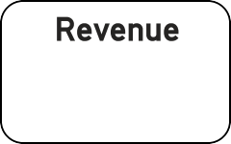
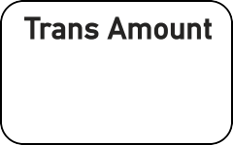
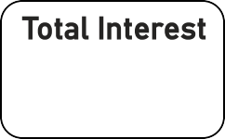


Grocery 9M

Food 8M

Travel 6M

Uneducated 8M Post-Graduate 3M
Doctorate 2M

Govt 8M

Blue-collar 7M

Retirees 5M
Blue

Silver 6M

Gold 3M

Platinum 1M
47M

Credit Card Customer Report
Week_Start_Date
All 

Revenue
Q3Q2Q1
Q4
Power BI Desktop

57M
Total Interest

8M
Income

588M
CSS

3.19
Revenue by Age Group

20-30
4M
6M
OnlineChip
Swipe
SilverBluePlatinum
Gold
M 31M F

0.8M

0.6M
Sum of Revenue

0.4M
Revenue by Week

30-40

40-50

50-60

60+

customer_job Sum of Revenue Sum of Interest_Earned Sum of income Blue-collar 70,40,606.42 967751 73516911
Businessman 1,76,97,472.01 2584604 190350431
11M
14M
Govt 83,35,533.84 1182231 90834727
Retirees 46,17,448.22 641692 49619308
Selfemployeed 85,42,826.40 1141510 77659931

Jan 2023 Apr 2023 Jul 2023 Oct 2023
9M
10M
Total 5,65,17,010.81 7982480 587599783

Top 5 States
5M
4M

11M

13M

13M

16M
Revenue by Marital Status
Revenue by Income Group
Revenue by Dependant Count
Revenue by Education level

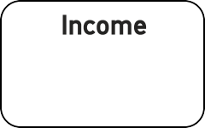


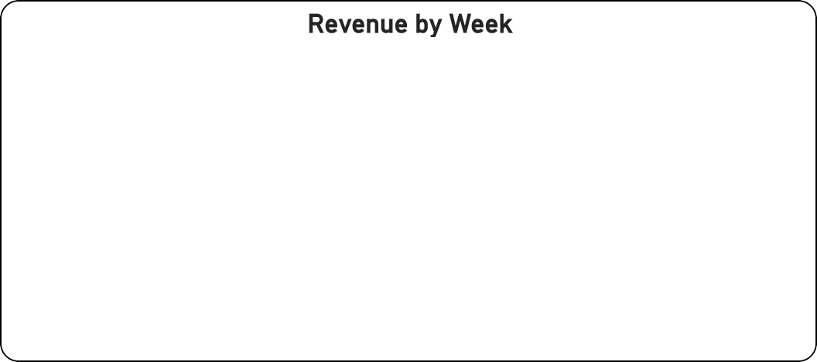
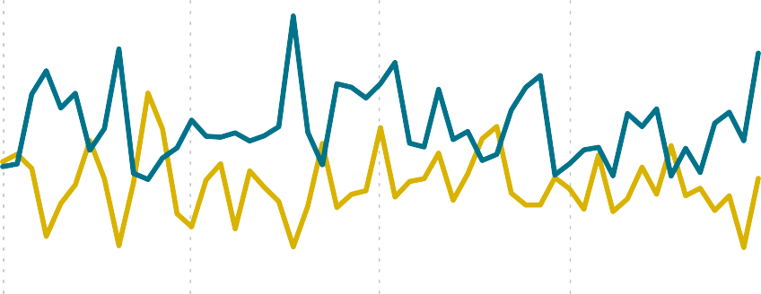
5M
5M
TX NY CA FL
4M
6M
7M
6M
6M
7M
6M
7M
NJ 3M

Married

Single

Unknown
2M
2M

High 4

7M
Med 8M

7M

23M

8M
2

10M

Low
0

Graduate High School Unknown
Uneducated 5M
8M
7M
6M
5M
9M
4M
13M
4M
10M

Post-Graduate

Doctorate

